APPENDIX 5
CULVERT LOCATION CONSTRAINTS

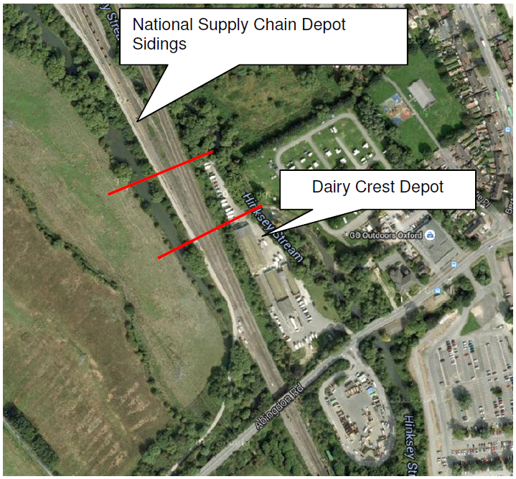
Source: Fig 4 p12 FRA

